ProFolio AI: Where Your Resume Meets Your Portfolio, Reimagined with AI

Project Description:
The Auto Resume + Portfolio Builder is an AI-powered full-stack web application designed to help users generate professional resumes and portfolio content quickly and efficiently. The system collects structured user information including personal details, education, skills, projects, experience, and certifications and uses Google Gemini AI to generate polished, role-customized resume content and portfolio sections.
The platform features a multi-page React frontend with template selection, a Node.js + Express backend API that communicates with the Gemini AI model, and a complete authentication system allowing users to save and manage their generated content. By reducing manual effort and simplifying the resume creation process, the system helps students and job seekers become career-ready in less time.

Scenarios:
Scenario 1: Student Resume Generation
A student preparing for campus placements fills in their education, skills, and project details through a guided form. The system uses Google Gemini AI to generate a professional resume with proper formatting and role-appropriate content, allowing the student to download and submit it immediately without requiring any design or writing skills.

Scenario 2: Portfolio Building for Job Seekers
A job seeker who already has resume data can use the Portfolio Builder to automatically create a structured personal portfolio from the same input data. The portfolio includes sections like About Me, Skills, Projects, and Achievements, and can be shared directly with potential employers or clients.

Scenario 3: Multi-Template Resume Customization
A user preparing applications for different job roles selects a template from the Templates section on the landing page and proceeds to the form. The system customizes the generated resume to suit the selected template style and the specified job role, ensuring the layout and content presentation align with industry standards.
Technical Architecture:
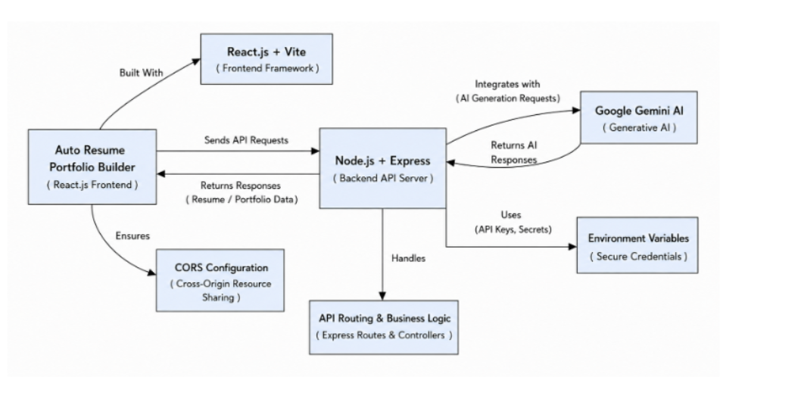
Description: ProFolio AI uses React.js + Vite for the frontend and Node.js + Express for the backend.
The backend connects with Google Gemini AI to generate personalized resume and portfolio content.
CORS enables frontend-backend communication, while environment variables secure API credentials.
The generated content is processed by the backend and displayed to the user through the frontend.

Prerequisites:
- React.js & Vite: Basic knowledge of React components, JSX, and Vite.
- Node.js & Express.js: Understanding of backend development, REST APIs, routing, and middleware.
- JavaScript: Familiarity with modern JavaScript (ES6+) and asynchronous programming.
- Google Gemini AI: Basic understanding of Generative AI and API integration.
- HTML & CSS: Knowledge of creating responsive and user-friendly web interfaces.
- Environment Variables & API Security: Understanding of .env files and secure API key management.
- Git & GitHub: Basic knowledge of version control and project management.

Project Workflow
Milestone 1: Requirement Analysis and Project Planning
Activity 1.1:
The first milestone focused on understanding the problem, identifying the target users, defining system requirements, and establishing the overall scope of the ProFolio AI project.
Activity 1.2:
Students and job seekers often face difficulties while preparing professional resumes and portfolios. Common issues include:
- Lack of professional resume-writing knowledge.
- Difficulty describing projects and experience.
- Uncertainty about relevant skills.
- Poor resume formatting.
- Lack of ATS awareness.
- Difficulty maintaining both a resume and portfolio.
- Repeated effort required to customize resumes for different opportunities.
To address these issues, ProFolio AI was proposed as an integrated AI-assisted career profile platform
Activity 1.3:
The major functional requirements identified were:
- Profile creation and editing.
- Education management.
- Experience management.
- Skills management.
- Project management.
- Resume generation.
- Portfolio creation.
- AI-assisted content generation.
- ATS resume analysis.
- Resume recommendations.
- Resume preview.
- Resume printing/PDF generation.
Activity 1.4:
The system was designed for:
- College students
- Fresh graduates
- Internship applicants
- Job seekers
- Professionals
- Freelancers
- Users from different career domains
Activity 1.5:
The planned workflow was:
User Input → Profile Creation → Resume Building → AI Assistance → ATS Analysis → Improvement → Portfolio Creation → Final Resume
Activity 1.6:
The requirements and scope of the project were finalized. The major functional modules and expected workflow were identified before implementation began.
Status: COMPLETED

Milestone 2: System Design and Technology Selection
Activity 2.1:
The second milestone focused on designing the system architecture, selecting suitable technologies, and planning the frontend, backend, and AI integration.
Activity 2.2:
The following technologies were selected:
Component | Technology
Frontend | React
Build Tool | Vite
Backend | Node.js
Server Framework | Express.js
AI Model/API | Gemini API
Programming Language | JavaScript
Package Manager | npm
Version Control | Git
Repository | GitHub
Development Environment | Antigravity / VS Code
Activity 2.3:
The system was designed using a client-server architecture.
Architecture Flow
User
↓
React/Vite Frontend
↓
Node.js/Express Backend
↓
Gemini API
↓
AI Processing
↓
Backend Response
↓
Frontend
↓
User
The frontend handles user interaction and presentation, while the backend manages server-side operations and communication with the Gemini API.
Activity 2.4:
A modern premium SaaS design approach was selected.
The interface includes:
- Blue and lavender visual identity.
- Rounded cards.
- Soft shadows.
- Glassmorphism-inspired elements.
- Floating UI components.
- Clean whitespace.
- Modern typography.
- Responsive layouts.
- Professional visual hierarchy.
The design was intended to avoid the appearance of a generic resume template website.
Activity 2.5:
The technology stack, system architecture, UI direction, and major application structure were finalized.
Status: COMPLETED

Milestone 3: Frontend Development and Core Modules
Activity 3.1:
The third milestone focused on implementing the primary user interface and core resume/profile functionality.
Activity 3.2:
The profile module was implemented to allow users to enter and manage their professional information.
The module supports information such as:
- Name
- Professional title
- Contact information
- Professional summary
- Social links
- Profile information
Activity 3.3:
The education section was developed to allow users to add academic qualifications.
Users can provide:
- Institution
- Degree
- Field of study
- Duration
- Relevant academic information
Multiple educational records can be managed.
Activity 3.4:
The experience section allows users to enter professional or internship experience.
Information includes:
- Organization
- Position
- Duration
- Responsibilities
- Achievements
Activity 3.5:
A flexible skills system was implemented.
Users can select or add skills relevant to their career field. The system was designed to support a wide range of professional domains rather than focusing only on software engineering.
Activity 3.6:
Users can add academic, personal, or professional projects.
Project information includes:
- Project title
- Description
- Technologies/tools
- Role
- Project link
Activity 3.7:
Users can add academic, personal, or professional projects.
Project information includes:
- Project title
- Description
- Technologies/tools
- Role
- Project link
Activity 3.8:
A resume preview interface was implemented so users can review the final appearance before printing or exporting it.
Activity 3.9:
The major frontend modules and core resume-building functionality were implemented and tested.
Status: COMPLETED
Milestone 4: AI Integration and ATS Analyzer
Activity 4.1:
The fourth milestone focused on integrating Artificial Intelligence and implementing intelligent resume-related features.
Activity 4.2:
Gemini AI was integrated into the application through the backend.
The communication flow is:
Frontend Request
↓
Express Backend
↓
Gemini API
↓
AI Response
↓
Backend
↓
Frontend
This approach ensures that the API key is not directly exposed to the frontend.

Activity 4.3:
The AI functionality can assist with creating and improving professional content such as:
- Professional summaries
- Experience descriptions
- Project descriptions
- Career-related content
- Resume improvements
- Skill-related suggestions
The generated content is returned to the application and can be used by the user while preparing their resume.
Activity 4.4:
An ATS Analyzer was implemented to evaluate resume content.
The analyzer considers factors such as:
- Relevant keywords
- Skills
- Job-role alignment
- Resume structure
- Formatting
- Content relevance
Activity 4.5:
The system provides an estimated ATS score to help users understand how well their resume may perform against automated screening systems.
The analysis can identify:
- Matching keywords
- Missing keywords
- Relevant skills
- Resume strengths
- Areas requiring improvement
Activity 4.6:
The system provides recommendations based on the analysis.
Examples include:
- Add missing job-specific keywords.
- Improve the professional summary.
- Add measurable achievements.
- Include relevant technical or domain-specific skills.
- Improve descriptions of projects and experience.
These recommendations are intended to guide the user and are not automatically inserted into the final resume.

Activity 4.7:
The Gemini API key was stored using an environment variable:
GEMINI_API_KEY
The actual .env file was excluded using .gitignore.
A .env.example file was used to indicate the required environment variable without exposing the actual secret.
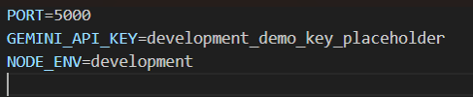

Milestone 5: Portfolio Development, Resume Output and UI Refinement
The portfolio builder was completed with sections for profile, skills, education, experience, projects, and achievements. The resume printing/PDF feature was also finalized. The interface was refined to provide a modern, responsive, and user-friendly experience.
Status: COMPLETED
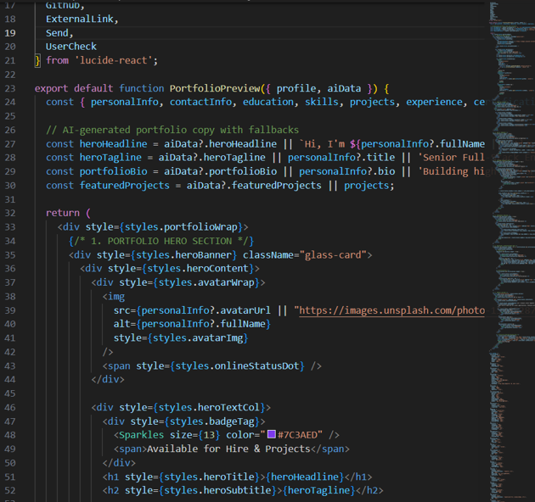

Milestone 6 : Testing & Version Control
The major features, AI integration, ATS Analyzer, resume generation, portfolio, and printing functionality were tested and necessary bugs were fixed. Git was used for version control, and the completed project was successfully uploaded to GitHub.
Status: COMPLETED
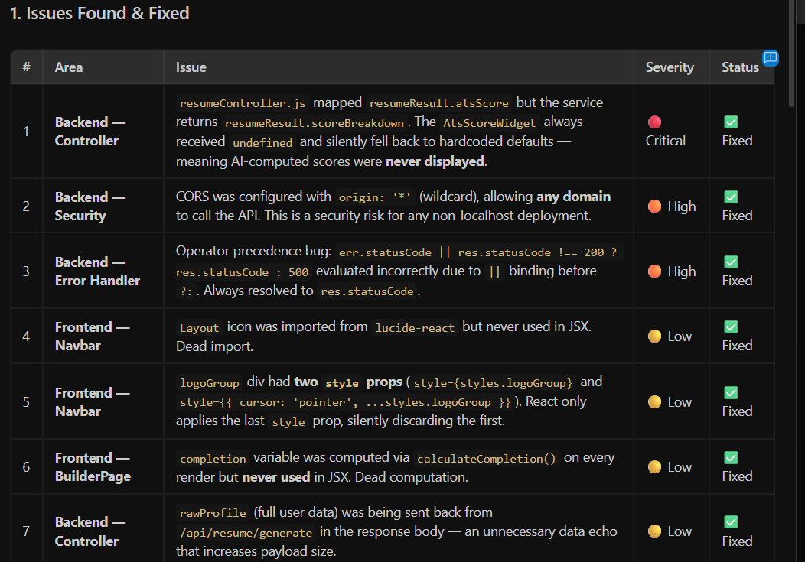

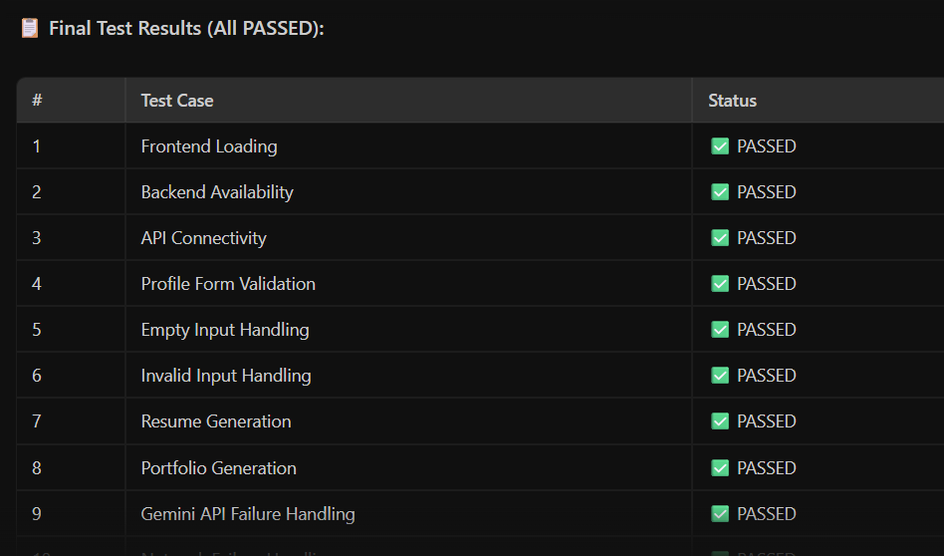

Milestone 7 – Final Validation
The complete application was tested as an integrated system. All major requirements were verified, API credentials were secured using environment variables and .gitignore, and the final GitHub repository was checked.
Status: COMPLETED

Final Project Status
ProFolio AI was successfully completed with all major planned features implemented, tested, and stored securely in the GitHub repository.

Conclusion:
ProFolio AI was successfully developed as an AI-powered resume and portfolio builder that simplifies professional profile creation. The system integrates resume building, portfolio creation, Gemini AI assistance, ATS analysis, personalized recommendations, and resume printing into a single platform. All major milestones were completed, the application was tested successfully, and the project was securely uploaded to GitHub. The system provides a strong foundation for future enhancements such as job matching, cloud storage, and personalized career guidance.

